Optional file marea_transit_powertrain_prop.csv
May 22, 2026
Definition of the Input File
VisionEval (https://visioneval.github.io/docs/model-inputs.html) explains that this optional file gives the mixes of transit vehicle powertrains. The user does not have to include this file it is only needed if the user wants to modify defaults. The nine attributes specify, for transit vans, transit buses, and transit rail, the proportion of vehicles using internal combustion engines, hybrid electric, or battery electric powertrains.
For example, based on the file below, an Marea that consisted only of Charlottesville city uses internal combustion enginers only for vans. For buses, such engines are 69.7% of the fleet, with 30.3% of the fleet being hybrid electric. There either is no rail service or if there is rail service, the default powertrains are used.
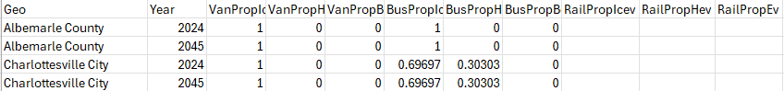
Possible Scenario
The document Task 7.2 Simplified Scenario Development guide available at A Playbook for Simplified Approaches for Creating Scenarios in VisionEval explains that “marea_transit_powertrain_prop.csv contains the mix of powertrains for transit vehicles.” One scenario is the impacts in terms of emissions of electrifying the transit fleet—say in the example above, changing the (presumably paratransit) vans from 100% ICEV to 50% ICEV and 50% hybrid (and perhaps comparing that to chaging the bus fleet from 30.3% hybrid to 80.3% hybrid.
Method Used for Virginia
Although the extrapolation method below gives 2024 and 2045 values, the research team believes that the short-term extrapoloation (to 2024) is reliable but the 2045 extrapoloation is speculative. Thus, the 2045 values are set to be equal to the 2024 values.
- Source: 2023 Annual Database Revenue Vehicle Inventory, National Transit Database (NTD)
  - URL: https://www.transit.dot.gov/ntd/ntd-data
  - Location: NTD Data–NTD Data Reports
  - Search Keyword: Revenue
  - Related Sheet: 2023 Revenue Vehicle Inventory

- Year that the Data Reflect: 2024 (The 2024 value was projected using data from 2021 to 2023.) 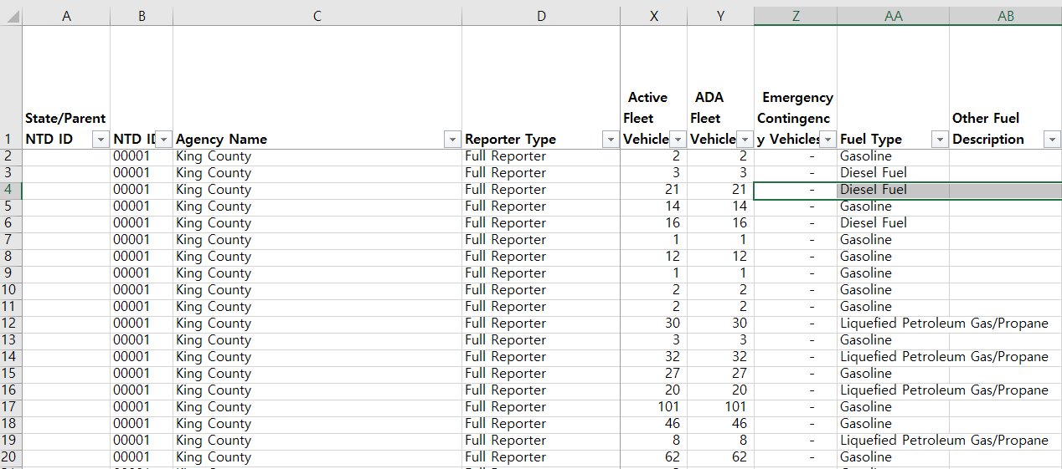

- How the Data Were Processed
  - Fuel Type Mapping: In VisionEval, fuel types must be entered as one of three categories: Internal Combustion Engine Vehicle (ICEV), Hybrid Electric Vehicle (HEV), or Battery Electric Vehicle (BEV) / Electrified Rail Vehicle (EV). Accordingly, the original fuel types were mapped to these three categories as shown below.
Fuel Type (NTD) | Category
Diesel Fuel | ICEV
Hybrid Diesel | HEV
Diesel Fuel/Electric Propulsion Power | HEV
Diesel Fuel/Liquefied Petroleum Gas/Propane | ICEV
Gasoline | ICEV
Hybrid Gasoline | HEV
Gasoline/Ethanol | ICEV
Gasoline/Compressed Natural Gas | ICEV
Gasoline/Liquefied Petroleum Gas/Propane | ICEV
Hybrid Gasoline/Liquefied Petroleum Gas/Propane | HEV
Compressed Natural Gas | ICEV
Liquefied Natural Gas | ICEV
Bunker Fuel | ICEV
Electric Battery | BEV/EV
Electric Propulsion Power | BEV/EV
Ethanol | ICEV
Hydrogen | Excluded
Liquefied Petroleum Gas/Propane | ICEV
Other | Excluded
  - Vehicle Type Mapping: The vehicle types provided by the NTD were mapped to the VisionEval input format as summarized below.
Vehicle Type (NTD) | Category
Articulated Bus | Bus
Bus | Bus
Double Decker Bus | Bus
Over-the-road Bus | Bus
School Bus | Bus
Trolleybus | Bus
Ferryboat | Excluded
Other | Excluded
Aerial Tramway | Excluded
Cable Car | Excluded
Commuter Rail Locomotive | Rail
Commuter Rail Self-Propelled Passenger Car | Rail
Light Rail Vehicle | Rail
Automated Guideway Vehicle | Rail
Heavy Rail Passenger Car | Rail
Inclined Plane Vehicle | Rail
Monorail Vehicle | Rail
Vintage Trolley | Rail
Commuter Rail Passenger Coach | Rail
Automobile | Van
Cutaway | Van
Minivan | Van
Sports Utility Vehicle | Van
Van | Van

  - Use of NTD IDs for Filtering: Unlike the 2023 TS2.1 Service Data and Operating Expenses Time Series by Mode, the 2023 Annual Database Revenue Vehicle Inventory does not include a field that allows for direct filtering by Virginia. Therefore, NTD IDs corresponding to Virginia agencies—identified in the TS2.1 dataset—were used for filtering, as shown below.
NTD ID | Agency Name | City | State
30006 | Greater Richmond Transit Company (GRTC) | Richmond | VA
30007 | Greater Roanoke Transit Company (GRTC) | Roanoke | VA
30008 | Greater Lynchburg Transit Company (GLTC) | Lynchburg | VA
30009 | City of Petersburg (PAT) | Petersburg | VA
30036 | City of Charlottesville (CAT) - Transit | Charlottesville | VA
30045 | JAUNT, Inc. | Charlottesville | VA
30053 | City of Bristol Virginia (BVT) - Transit Department | Bristol | VA
30058 | City of Fairfax (CUE) - Transportation Division in the Public Works Department | Fairfax | VA
30068 | Fairfax County, VA - Transportation | Fairfax | VA
30069 | City of Danville - Mass Transit | Danville | VA
30070 | Potomac and Rappahannock Transportation Commission (PRTC) | Woodbridge | VA
30071 | City of Alexandria - Department of Transportation and Environmental Services/Transportation Branch | Alexandria | VA
30073 | Virginia Railway Express (VRE) | Alexandria | VA
30076 | Williamsburg Area Transit Authority (WATA) | Williamsburg | VA
30079 | City of Fredericksburg (FRED) - Transit Department | Fredericksburg | VA
30080 | Arlington County, Virginia (ART) - Department of Environmental Services | Arlington | VA
30081 | Loudoun County - Transit Division - Department of General Services | Leesburg | VA
30083 | Transportation District Commission of Hampton Roads (HRT) | Hampton | VA
30091 | Town of Blacksburg (BT) - Transit | Blacksburg | VA
30094 | City of Harrisonburg (HDPT) - Department of Public Transportation | Harrisonburg | VA
30099 | City of Winchester - Winchester Transit | Winchester | VA
30114 | Accomack-Northhampton Transportation District Comm - Public Transportation | Tasley | VA
30115 | New River Valley Senior Services, Inc. (PAT) - Public Transportation | Radford | VA
30118 | Virginia Regional Transit (VRT) | Purcellville | VA
30123 | District Three Governmental Cooperative | Marion | VA
30132 | Mountain Empire Older Citizens - Transit | Big Stone Gap | VA
30142 | Lake Country Area Agency on Aging - Transportation | South Hill | VA
30157 | Town of Altavista (ACTS) - Transportation | Altavista | VA
30164 | Town of Bluefield - Transit | Bluefield | VA
30165 | Town of Farmville (FAB) | Farmville | VA
30172 | Bay Aging - Public Transportation | Urbanna | VA
30174 | Appalachian Agency for Senior Citizens - Public Transit | Cedar Bluff | VA
30178 | Unified Human Services Transportation Systems, Inc (RADAR ) | Roanoke | VA
30184 | Town of Blackstone (BABS) | Blackstone | VA
30198 | City of Suffolk - Public Works | Suffolk | VA
30200 | City of Radford - Transportation | Radford | VA
30203 | York County - Tourism | Yorktown | VA
30204 | Colonial Williamsburg Foundation (CWF) | Williamsburg | VA
30989 | Central Shenandoah Planning District Commission (CSPDC) | Staunton | VA
31025 | County of Greensville (GET) - Transportation | Emporia | VA

  - Aggregation Using Excel: The 2021-2023 data were aggregated using the sumifs function in Excel, as summarized in the table below. 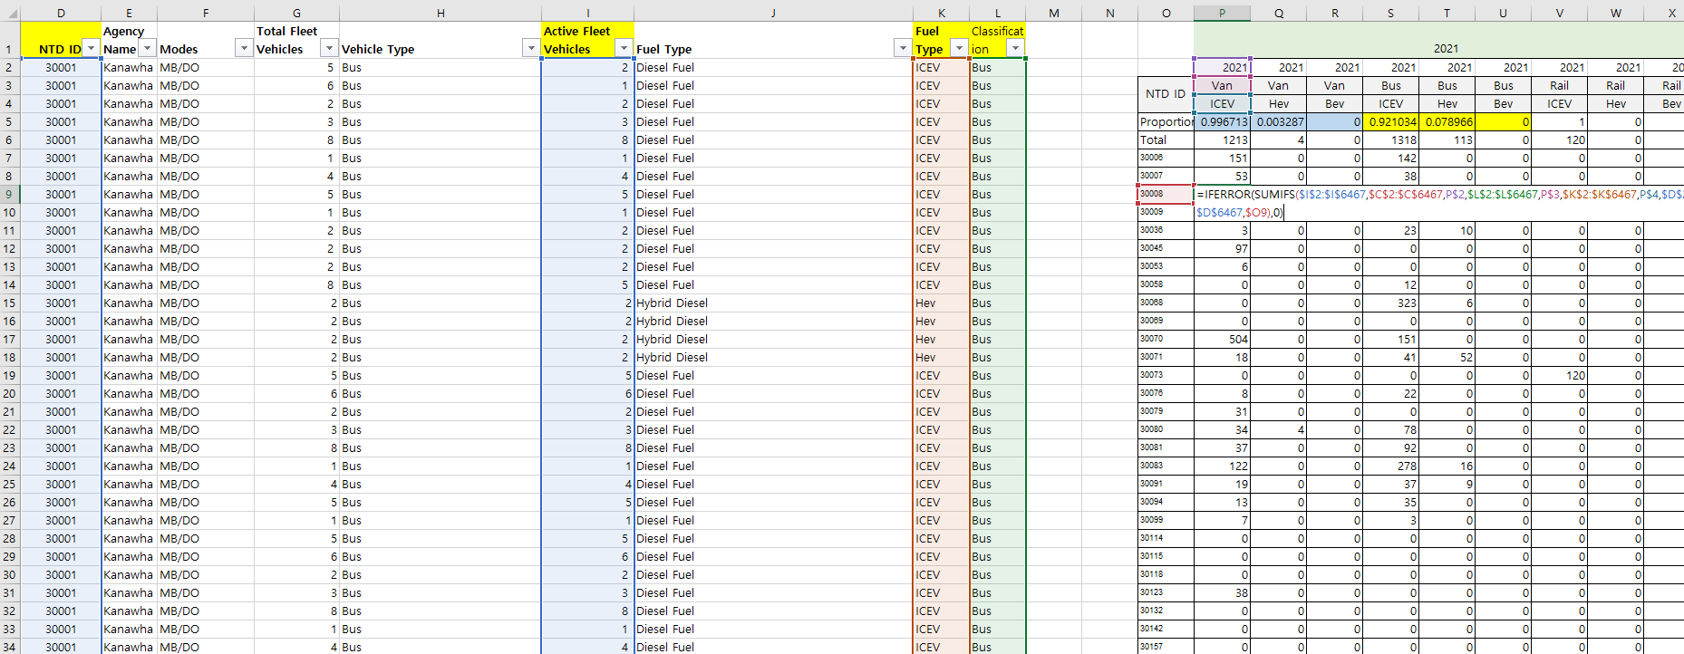

  - Base Year and Target Year Values Projection: The 2024 base year values were projected using the compound annual growth rate (CAGR) calculated from 2021 to 2023. For the target year, instead of applying individual growth rates, a generalized total growth rate was used across all categories. 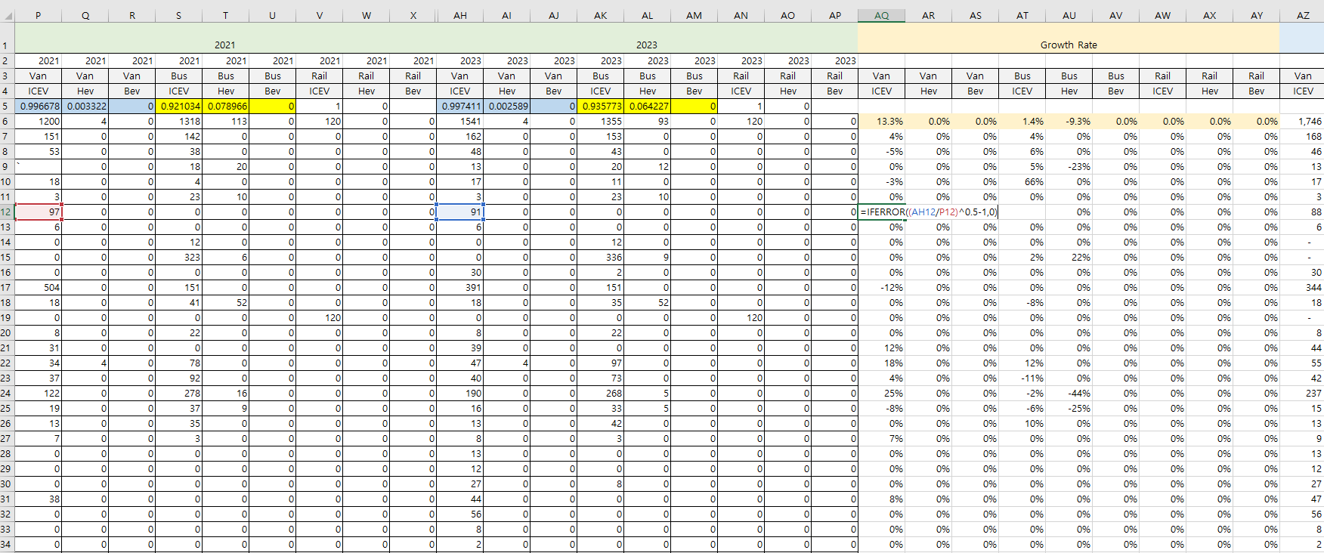 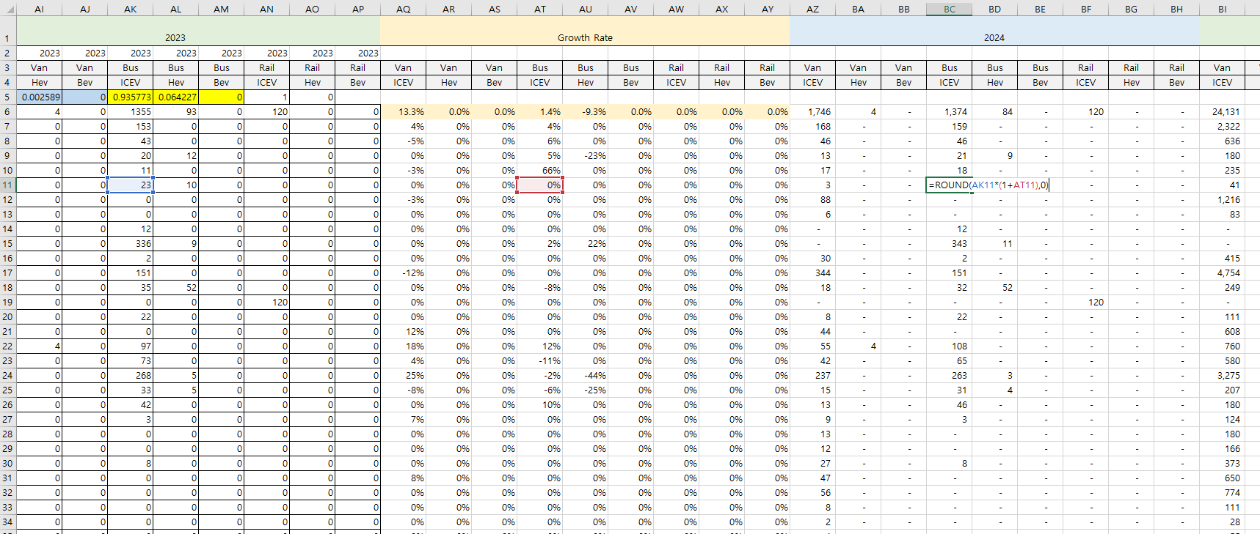

  - Classification Based on Marea Geography: To ensure consistency with the geographic structure used in other marea_* input files, the data were reorganized as shown below. 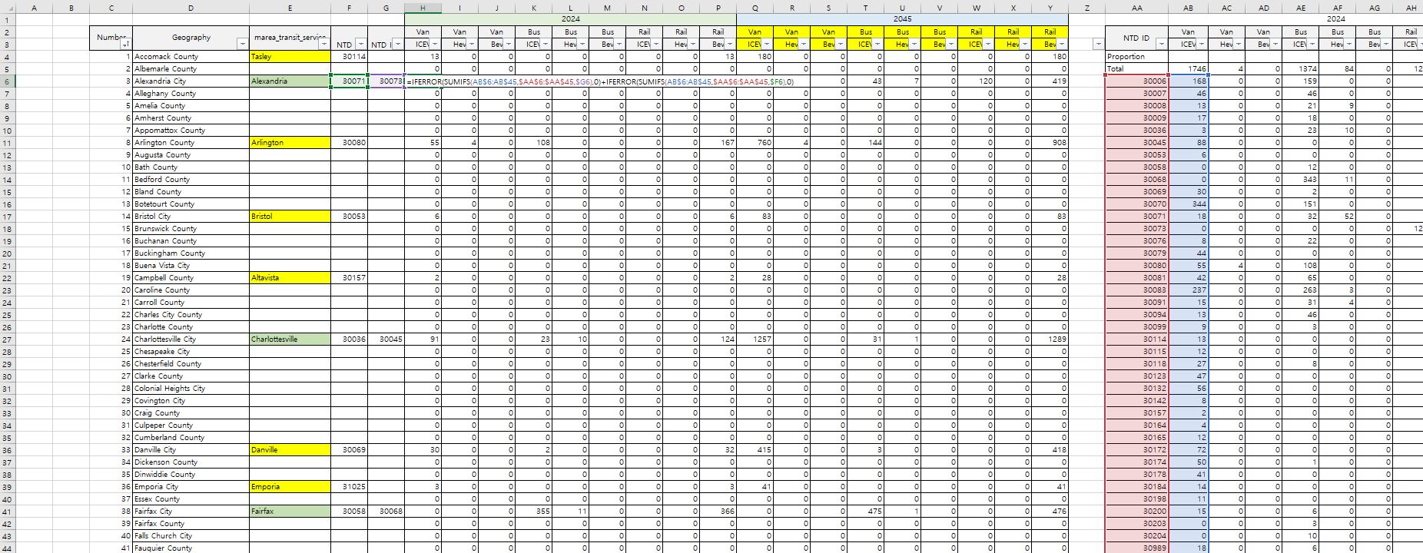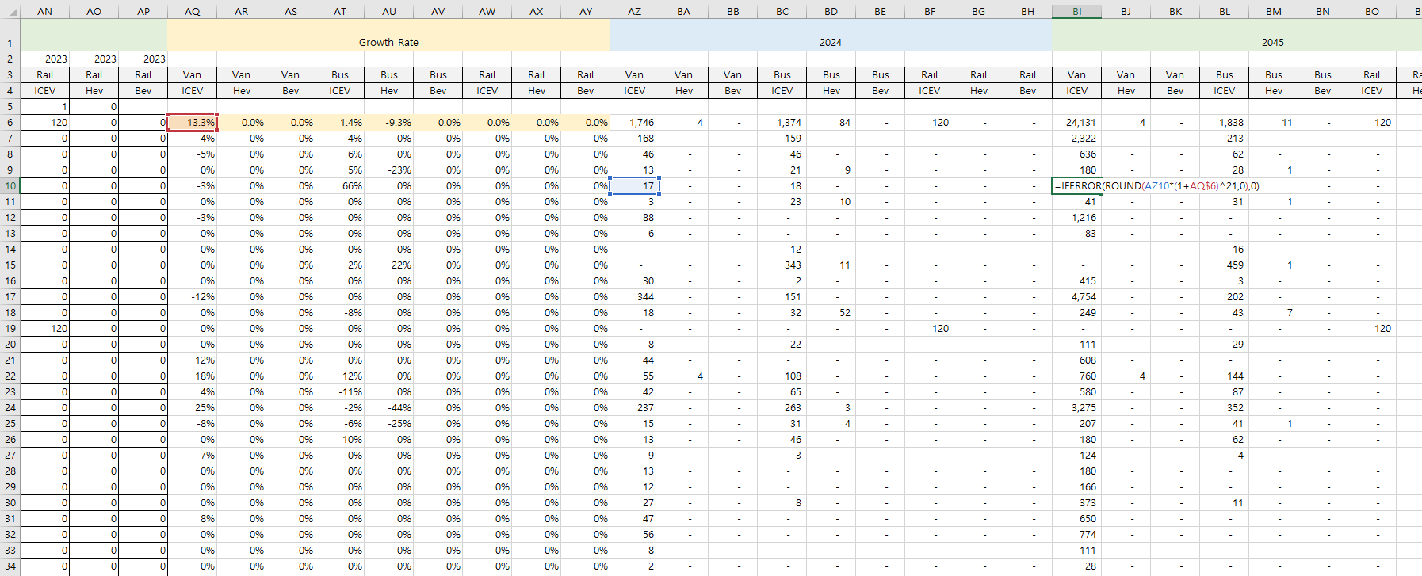

Note: Some cities, such as Charlottesville, are associated with more than one NTD ID. Care should be taken to avoid double counting when aggregating data.

  - Ratio Calculation and Final Result: Final input values were calculated based on the derived ratios and aggregated data.
Note: To prevent the VisionEval crashes, specific vehicle type does not exist within a county or city, the value in the input files should be entered as NA instead of 0.

